**COAL LAB 8**

Q.1)

Include Irvine32.inc

.data

arr1 word 2,4,6,8,10,12,14,16,18,20

arr2 word 10 dup(0)

comma byte ",",0

.code

main proc

mov edx,0

mov edx,offset comma

mov esi,offset arr1

mov ecx,10

l1:

mov eax,0

push [esi]

mov ax,[esi]

call writedec

call writestring

add esi,2

loop l1

call crlf

call crlf

mov esi,0

mov esi,offset arr2

mov ecx,10

l2:

mov eax,0

pop eax

movzx eax,ax

mov [esi],eax

call writedec

call writestring

add esi,2

loop l2

call crlf

call crlf

exit

main endp

end main

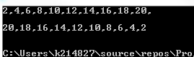

Q.2)

Include Irvine32.inc

.data

arr1 DWORD 2,2,2,2,2

arr2 DWORD 3,3,3,3,3

s1 DWORD ?

s2 DWORD ?

.code

main proc

call Addarr1

exit

main ENDP

Addarr1 PROC

mov esi,offset arr1

mov eax,0

Mov ecx,5

l1:

add eax,[esi]

add esi,4

loop l1

call writedec

call crlf

mov s1,eax

Call Addarr2

Ret

Addarr1 ENDP

Addarr2 PROC

mov esi,offset arr2

mov eax,0

Mov ecx,5

l2:

add eax,[esi]

add esi,4

loop l2

call writedec

call crlf

mov s2,eax

call AddSums

Ret

Addarr2 ENDP

AddSums PROC

call crlf

mov eax,s1

add eax,s2

call writedec

call crlf

ret

AddSums ENDP

end main

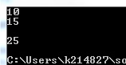

Q.3)

Include Irvine32.inc

.data

col DWORD ?

msg byte "Enter number of columns: ",0

space byte " ",0

.code

main proc

mov edx,offset msg

call writestring

call readint

call printstar

exit

main ENDP

printstar PROC

mov col,eax

mov eax,0

mov al,'*'

mov edx,offset space

mov ecx,col

l:

call crlf

mov ebx,0

push ecx

mov ebx,ecx

mov ecx,ebx

l1:

call writestring

loop l1

mov ebx,col

inc ebx

pop ecx

sub ebx,ecx

push ecx

mov ecx,ebx

l2:

call writechar

loop l2

pop ecx

loop l

ret

printstar ENDP

end main

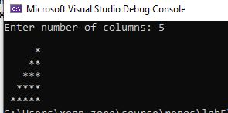

Q.4)

Include Irvine32.inc

.data

col DWORD ?

msg byte "Enter number of columns: ",0

space byte " ",0

.code

main proc

mov edx,offset msg

call writestring

call readint

call printALPHABETS

exit

main ENDP

printALPHABETS PROC

mov col,eax

mov eax,0

mov ax,65

mov edx,offset space

mov ecx,col

l:

call crlf

mov ebx,0

push ecx

mov ebx,ecx

mov ecx,ebx

l1:

call writestring

loop l1

mov ebx,col

inc ebx

pop ecx

sub ebx,ecx

push ecx

mov ecx,ebx

l2:

call writechar

inc eax

loop l2

pop ecx

loop l

ret

printALPHABETS ENDP

end main

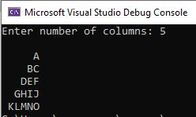

Q.5)

Include Irvine32.inc

.data

n DWORD ?

msg1 byte "Enter number n: ",0

msg2 byte "Sum of numbers from 1 to n: ",0

plus byte " + ",0

.code

main proc

mov edx,offset msg1

call writestring

call readint

call printsum

call crlf

exit

main ENDP

printsum PROC

mov n,eax

mov eax,0

mov ebx,0

mov ecx,n

l1:

push ecx

loop l1

call crlf

call writedec

mov ecx,n

l2:

pop eax

mov edx,offset plus

call writestring

call writedec

add ebx,eax

loop l2

call crlf

call crlf

mov edx,offset msg2

call writestring

mov eax,ebx

call writedec

ret

printsum ENDP

end main

